**Life in the middle ages**

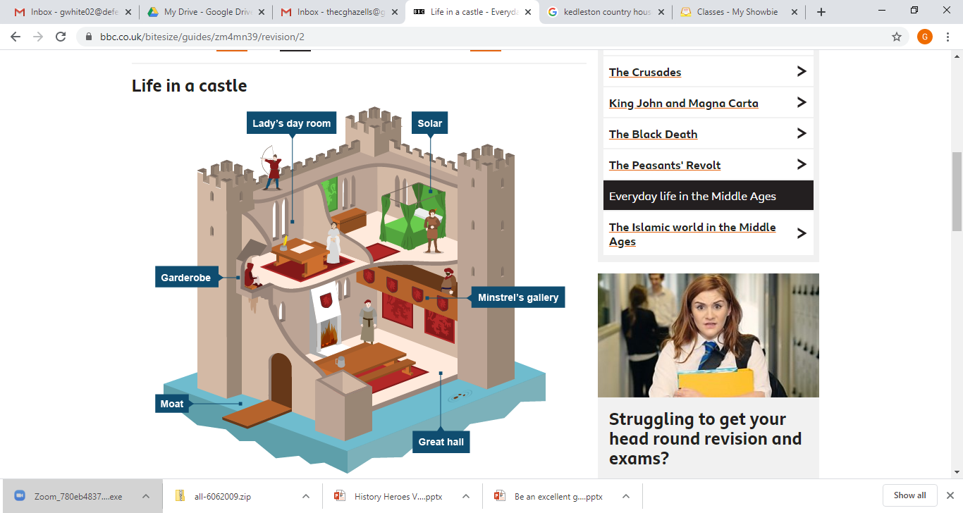

* The great hall was the centre of a castle and the walls were decorated with tapestries. There was a minstrel gallery for musicians and singers.
* The great hall would have at least one fireplace with a chimney. This was a Norman invention and stopped the room filling with smoke.
* The toilet, called the 'garderobe', was usually a chute straight into the moat. One way to capture a castle was to climb up the chute, keeping your fingers crossed that the toilet wasn't occupied!

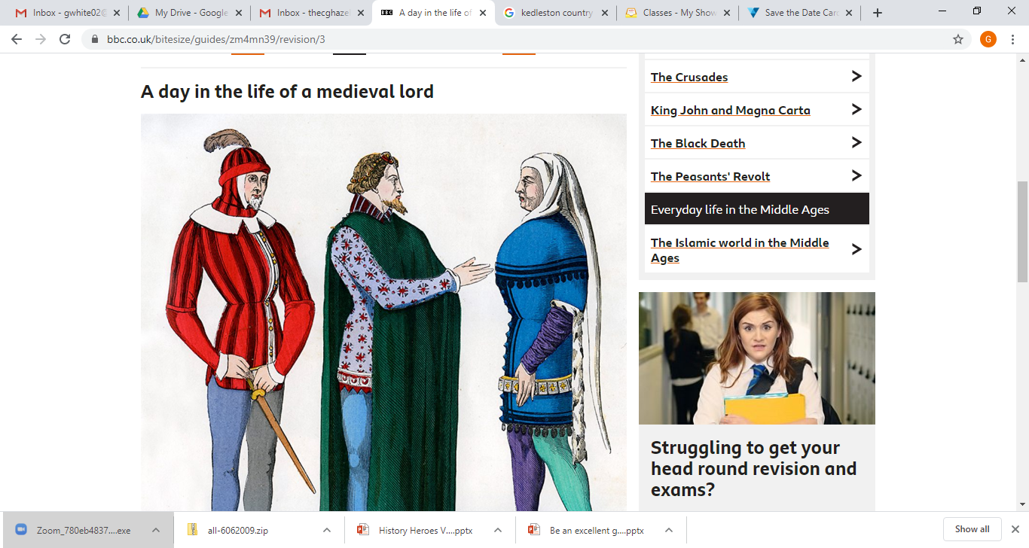

* Many nobles lived in castles. Everyone except the lord sat on benches. The servants slept on the floor.
* The lord had his own room, called the solar, and his own four-poster bed, with curtains for privacy.
* At the top of the castle, the lady would have a day-room for herself and her maids-in-waiting.
* Nobles had meals that had many courses. Each course consisted of many kinds of meats including swan, peacock, magpie, porpoise and boar. This was served on a thick bread 'trencher' and eaten with a knife and the fingers.
* Nobles ate few vegetables. If the lord was entertaining guests, he might impress
* Almost every lord loved hunting.

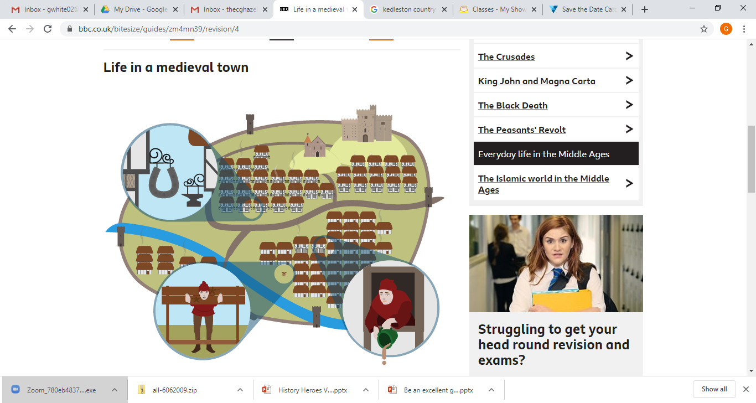

* Houses were made of a wooden frame, with the gaps filled with woven strips of wood, known as 'wattle', and covered, or 'daubed', with clay and horse-dung. Most roofs were thatch.
* As few people could read, shops signs were a huge model showing the craftsman's trade. People of the same trade often worked in the same street.
* The streets of a medieval town were narrow and busy. They were noisy, with the town crier, church bells, and traders calling out their wares. There were many fast food sellers, selling such things as hot sheep's feet and beef-ribs.
* Towns were full of human waste, mud and animal dung. The smells in towns was gut-wrenching. Disease spread easily as a result of poor hygiene and no knowledge of bacteria or dirt

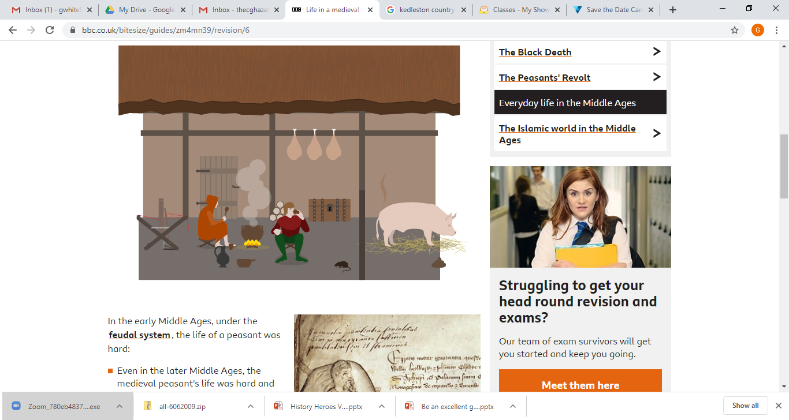**Life for a medieval peasant**

In the early middle Ages, under the feudal system, the life of a peasant was hard:

* Even in the later middle Ages, the medieval peasant's life was hard and the work back-breaking. It followed the seasons – ploughing in autumn, sowing in spring, harvesting in August. Work began at dawn, preparing the animals, and it finished at dusk, cleaning them down and putting them back into the stalls.
* A peasant's hut was made of wattle and daub, with a thatch roof but no windows.
* Inside the hut, a third of the area was penned off for the animals, which lived in the hut with the family. Furniture was maybe a couple of stools, a trunk for bedding, and a few cooking pots.
* Peasant food was mainly vegetables, plus anything that could be gathered – nuts, berries, nettles. The usual drink was weak, home-brewed beer.
* The most difficult time was late spring, when food stores were running out, and new food was not yet growing. A poor harvest meant that some of the villagers would starve to death.